IGEL Reporting – SQL Reporting Services Configuration

Contents

**Introduction** 3

**SSRS Configuration** 3

# **Introduction**

This document walks you through on how to configure SQL Reporting Services (SSRS). The purpose of this is to show you how to configure a baseline configuration for SSRS (either for testing or if an SSRS environment does not exist). Please consult with your DBA for recommended configuration settings in a Product Environment.

# **SSRS Configuration**

The following steps need to be completed to configure SSRS

***Note*** *– This document assumes the SSRS service has been installed on an endpoint and there’s communication from this endpoint to the database server hosting the IGEL database. For the latest release of SSRS 2019, please click the following link:* [*SSRS 2019*](https://www.microsoft.com/en-us/download/details.aspx?id=100122)

1. On the endpoint in which SSRS was installed, open Report Server Configuration Manager

***Note*** *- an account with elevated permissions is required to run this*

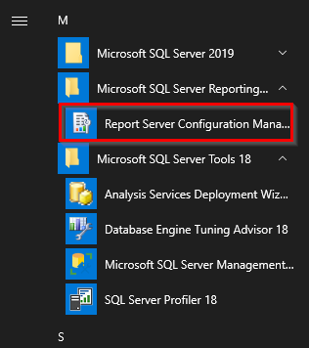

2. Once you have opened and connected to Report Server Configuration Manager, select the option for Web Service URL and then click **Apply** to enable the web service URL.

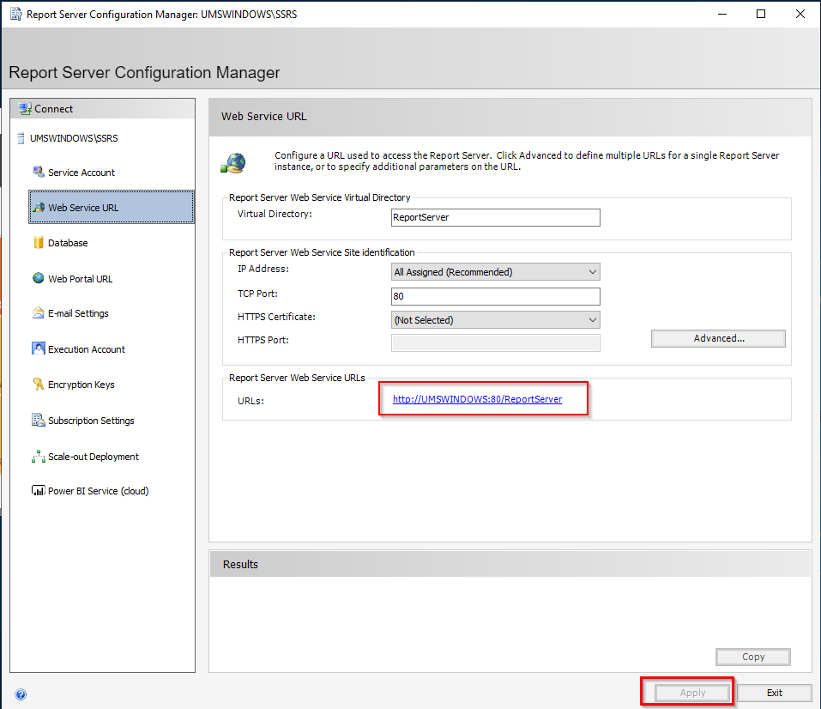

3. Next select the Database and **Change Database**

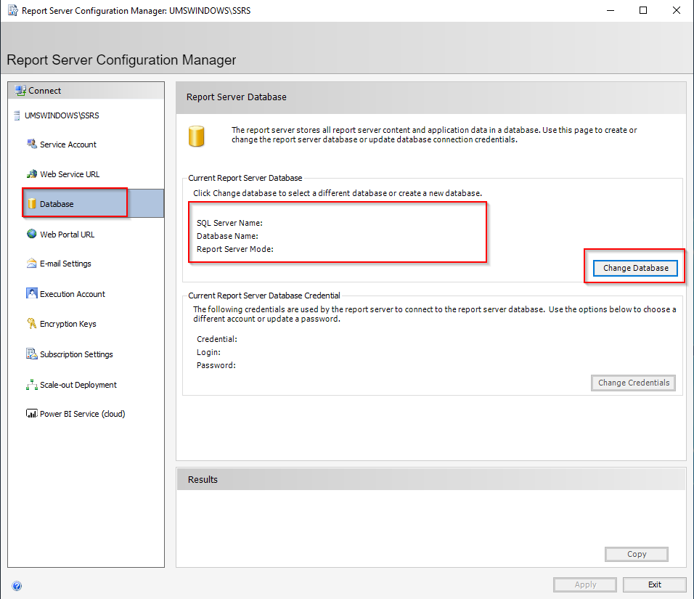

4. Within the wizard select **Create a new report server database** and click Next

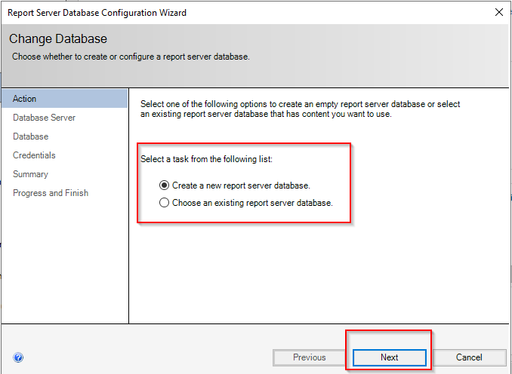

5. Select the server and/or instance name of the SSRS installation and then select the Authentication Type and account that will have access this database

Test the connection before clicking **Next**.

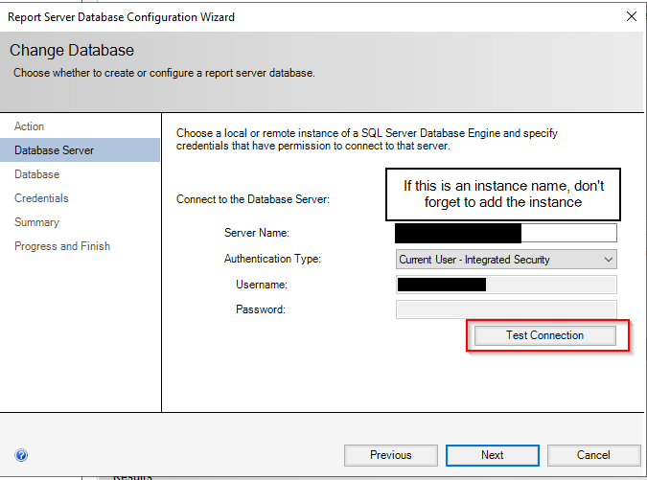

6. Select the Database Name or leave it as default (ReportServer) and click **Next**, review the changes, and click **Next**. The Report Server database will now be created. Once installed the database configuration section should look like something like this:

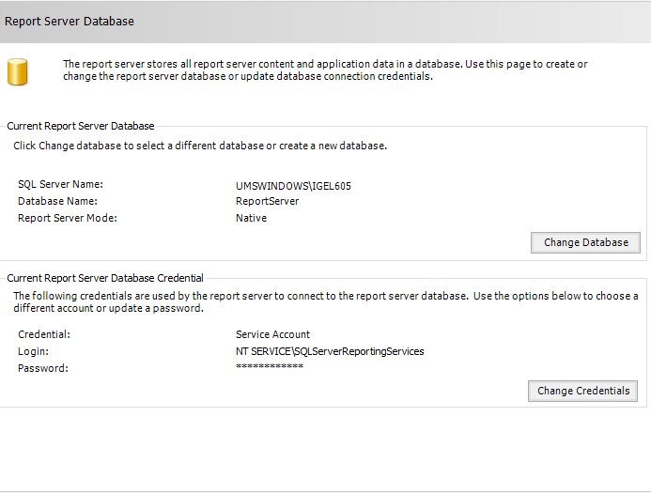

7. Lastly, select the Web Portal URL item and click **Apply** to enable the management portal in SSRS.

